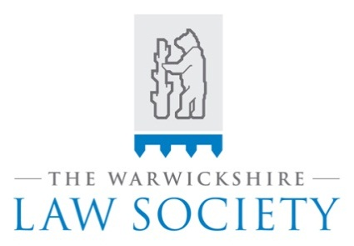

LEGAL TEAM OF THE YEAR 2024
Sponsored by 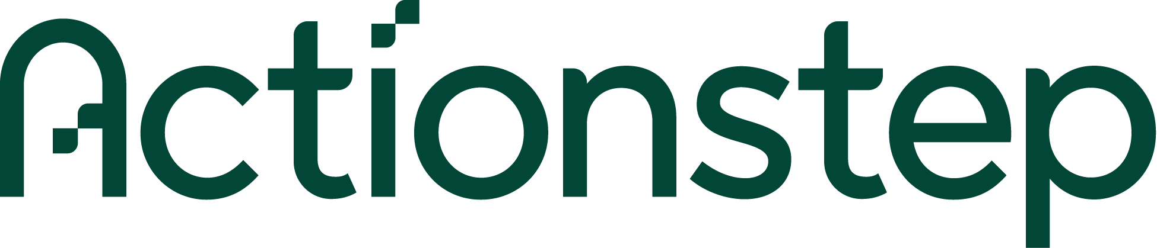
NOMINATION FORM

“Why should you or your legal team be crowned Legal Team of the Year?”

We are delighted to open nominations for this year’s exciting Legal Team of the year 2024 competition. The search is now on, and the clock ticking, to find the Legal Team that is worthy of being awarded this year’s prestigious award!

Lawyers, Companies or Organisations can put forward nominations in the traditional way, there are no restrictions on numbers of nominations. The only factors which must be adhered to are:

- Eligibility is restricted to Legal Teams from firms who are members of the society
- Nominee is expected to be a member of the Society

The attached nomination form has been greatly streamlined. You just need to tell us, in less than 500 words, why you think the Legal Team you are nominating, should be considered for this award and return the application form to us by no later than Monday 7th October 2024.

The nominations will be considered by a panel of three judges, with the winner being announced at the Society’s Annual Dinner at Nailcote Hall, Berkswell on Friday 8 November 2024 with the winner being presented with an engraved glass trophy, which will be the winners to keep.

Please take the time to participate.

Robert Lee
President

Sponsors:

LEGAL TEAM OF THE YEAR 2024

NOMINATION FORM

FIRM /NOMINEES NAME:

NAME OF NOMINATOR:

CONTACT DETAILS:

SECTION TO BE COMPLETED BY EITHER NOMINEE or NOMINATOR
(In less than 500 words):

PLEASE COMPLETE AND RETURN NOMINATION FORM TO:

lesley@warwickshirelawsociety.com

Mrs L. Hazell, The Warwickshire Law Society,
Address: PO Box 6469, Coventry, CV6 9LY

by no later than Monday 7th October 2024

With grateful thanks to the Sponsors of this Award:

